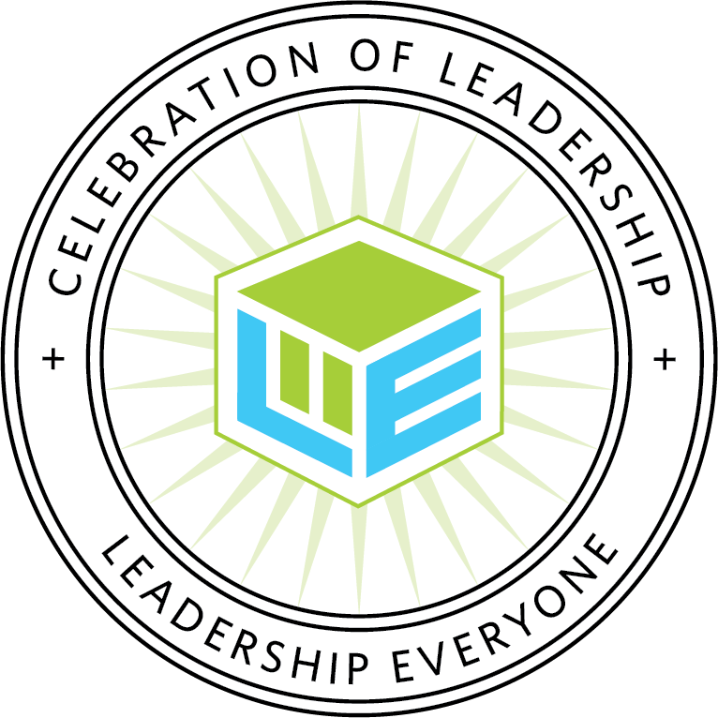
24th Annual Celebration of Leadership
Award Recipients

INDIVIDUAL
Arts | Todd Huber
Community & Neighborhood | Marci Hall
Education | Marvin Smith
Government, Public Service, & Environment | Kris Holzmeyer
Health & Social Services | Kelly Salee
DIVISION RECIPIENT - Winternheimer/LaMar Public Service Award | Dave Wedding
PROJECT OR PROGRAM
Arts | ARTS-N-THE PARK
Community & Neighborhood | Castle High School Riley Dance Marathon Board
Education | Carver Community Organization AARP Foundation Experience Corps
Government, Public Service, & Environment | American Red Cross Services to Armed Forces Totes of Hope
Health & Social Services - Program | Community Job Link through The Arc of Evansville
Health & Social Services - Project | Neighborhood Baby Shower
DIVISION RECIPIENT - Community Collaboration Award | Honor Flight of Southern Indiana, Inc.
BUSINESS OR ORGANIZATION
Arts | Evansville Civic Theatre, Inc.
Community & Neighborhood | Diamond Galleria
Education | Optimal Rhythms/ACCESS Academy
Government, Public Service, & Environment | Downtown Evansville Economic Improvement District
Health & Social Services | Just Stylin Salon
DIVISION RECIPIENT - Integrity Award | Family Matters of Posey County
SPECIAL PRESENTATIONS
The Spirit Award | EPD Mounted Patrol
Sam Featherstone Youth Award - Project or Program | Dare to Dream
Sam Featherstone Youth Award - Project or Program | UE’s Mad Hot Ballroom
Sam Featherstone Youth Award - Business or Organization | South Side Stars Youth Zone
Sam Featherstone Youth Award - Overall | Lorelei Taylor
Bryce Jordan Servant Leader Award | Lincoln Food Pantry
Susan Kelley Jordan Courage Award | 414 Collective
Leader in Technology Award | Debbie Calhoun
Lieutenant Colonel Reginald Gibson Award | Carisa Campbell
Willie Effie Thomas Diversity Award | Lori Sutton
Shirley James “Greening the Community” Award | EVSC Solar Field Project
Nancy Sieben Koehler Sustainability Award | 100 Guys Who Care/100+ Women Who Care
Darrell Ragland Award | Arlinda Payne
Sara B. Davies Award | Jack Miller
Outstanding Innovation Award | Harwood Career Preparatory High School
Transformational Inclusion Award | MASIHA Specialty Clinic
Regional Impact Award - Individual | Jeff Whiteside
Regional Impact Award - Project or Program | A Year of Hip Hop
Regional Impact Award - Business or Organization | Linda E. White Hospice House
Civic Engagement Award | Mickey's Kingdom Playground
Civic Engagement Award - Individual | Hannah Jaramillo
Lifetime Award | Alfred Savia

